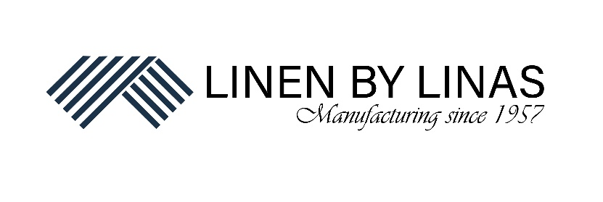

UAB „Linas LT“ Name Surname
S.Kerbedzio str.23, Panevezys ID 00000000
Įm. kodas 301733421
Director

APPLICATION
FOR MONEY REFUND

20____-____-____
Panevezys

Please return money for my item (name of the item), which I bought in e-shop “Linen By Linas” on (name the day of the purchase). Reason of money return: (name the reason). I confirm that the item is not used or damaged in any other way. Please refund the amount (indicate the amount in numbers) to my bank account:
Bank: …………………………
Bank account: ……………………………….
SWIFT: ……………………………………..

Client Name Surname

(signature)

